Government of Pakistan  Prime Minister Secretariat (Public)  Earthquake Reconstruction and Rehabilitation Authority (ERRA)  Islamabad | 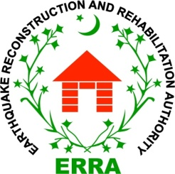

Date: September, 27, 2016
Press Release

Bosnian Ambassador call on Deputy Chairman ERRA

Islamabad, September 27, 2016, (PR): The Ambassador of Bosnia Dr. Nedim Makraevic called on Acting Deputy Chairman Brig. Abu Bakr Amin Bajwa here at ERRA Headquarters today and discussed matter of mutual interests.

During the meeting Deputy Chairman appreciated Bosnian government’s good will gesture for participation in construction of Basic Health Unit in Chatter Klass which is providing health facilities to around 20,000 patients yearly of Azad Kashmir and Hazara division.

He also thanked Bosnian government for the construction of government Girl Middle School in Dana Khacheli Muzaffarabad which was latter on upgraded to High School. He added that people of earthquake affected areas will remember the kind gesture of Bosnian people and their government for school.

Bosnian Ambassador Dr. Nedim Makraevic appreciated ERRA’s relentless efforts and work in earthquake affected areas and appreciated the up gradation from Middle to High School for girls.
He said that Bosnia will always stand by Pakistan efforts to alleviate misery of affected people of Khyber Pakhtunkhwa and Azad Kashmir.

End

